Problem: **Bring Order in BPP**

Document Attributes

| Attribute | Value |
| --- | --- |
| Application ID / Application Name | BPP - CKT-VOICE |
| Owner | Rahul Bathla |
| Owner Contact Information | RB824N |
| Problem Abstract | Load Order |
| Other Attribute |  |

Before we go any further-Below are the links and screen shots for GUI which we most commonly used

<http://bppcktv.it.att.com:8000/prod-sup/>

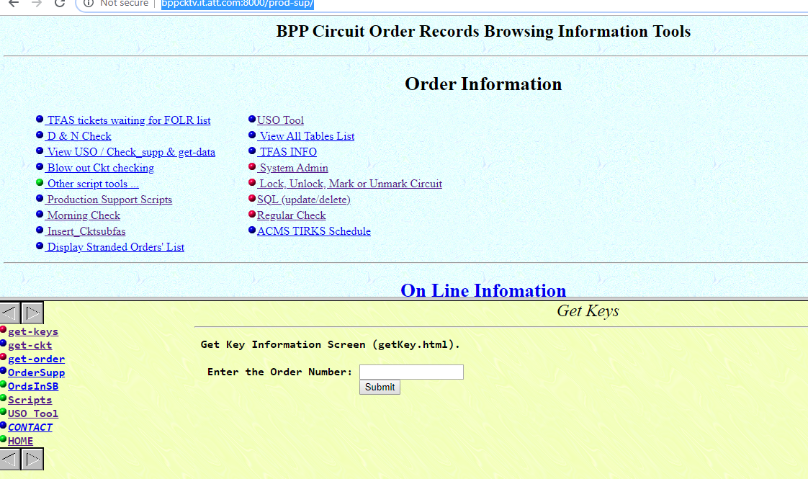

<http://bppcktv.it.att.com:8000/sql/index.html>

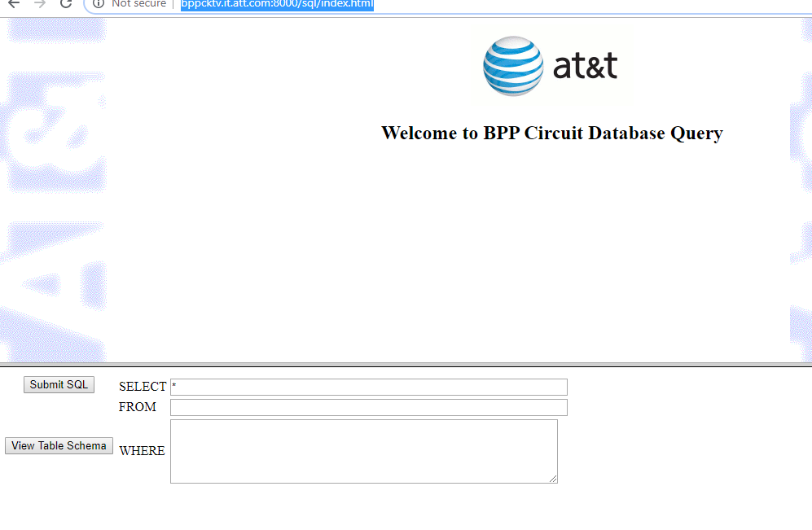

3. <http://bppcktv.it.att.com:8000/prod-sup/wrapper/ps-index.html>

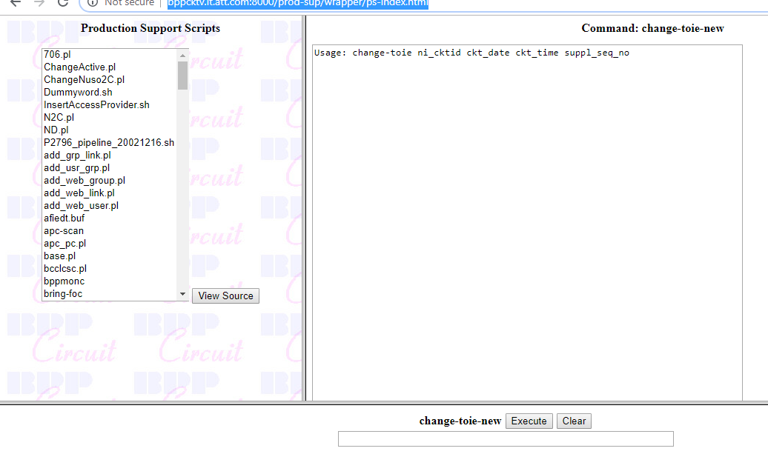

4. <http://bppcktv.it.att.com:8000/prod-sup/dm_frame.html>

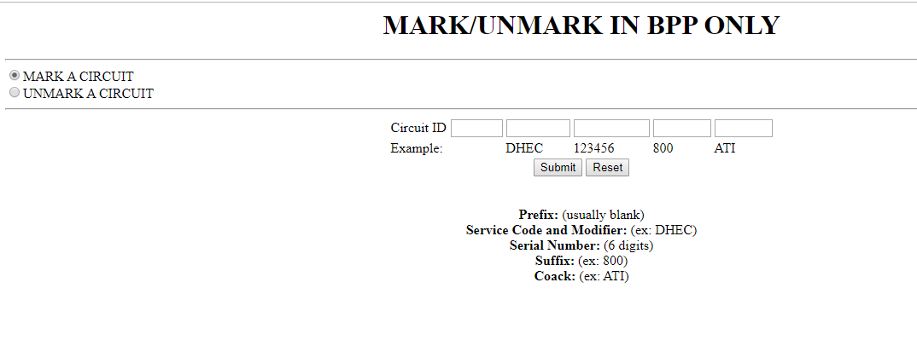

Now As per the information provided during overview , order in ticket mentioned below fell out of automation process now we have to work on it manually step by step.

Points to keep in Mind-

* User can have different description for same issues
* On several instance User Create Tickets but Order get picked up by automation in Next Round
* In Several Instance User will ask you to perform last Step (example: Issue WORD) and even first step has not been started

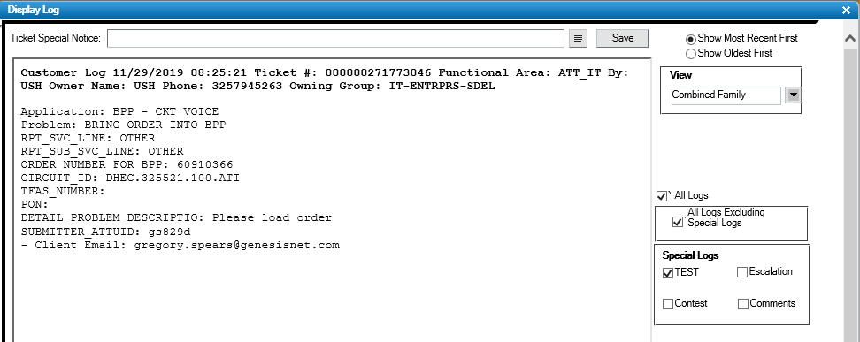

1. Go to “SIFUSO” Table and check the Info like insertion Date, CKT, Connect Or Disconnect or QRD order.

SELECT * FROM SIFUSO WHERE ORDER_NO in ('60910366')

There are cases but very rare that there is no information in SIFUSO about the order. In that case you pick CKT information from Ticket and run the query accordingly (Refer Screen Shot B)-

SELECT * FROM SIFUSO WHERE SPL_SERSERNO='XXXXXX'

SERSER_No is CKT Number as well

A.

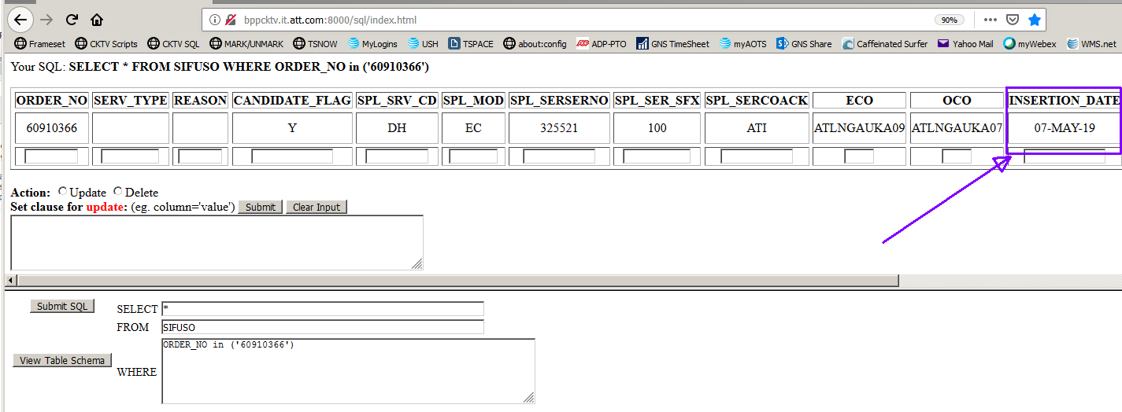

B.

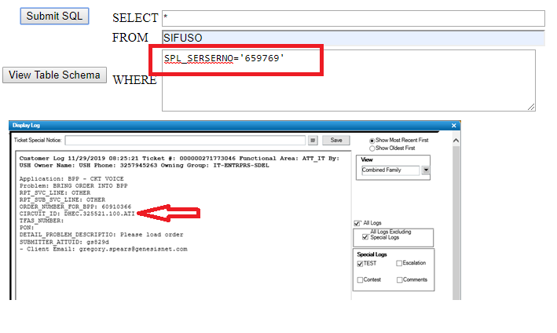

**2** Enter the order no. from the USH ticket in GetKeys (BPP GUI) "Enter the Order Number:" field -- then click SUBMIT button. URL: http://bppcktv.it.att.com:8000/prod-sup/

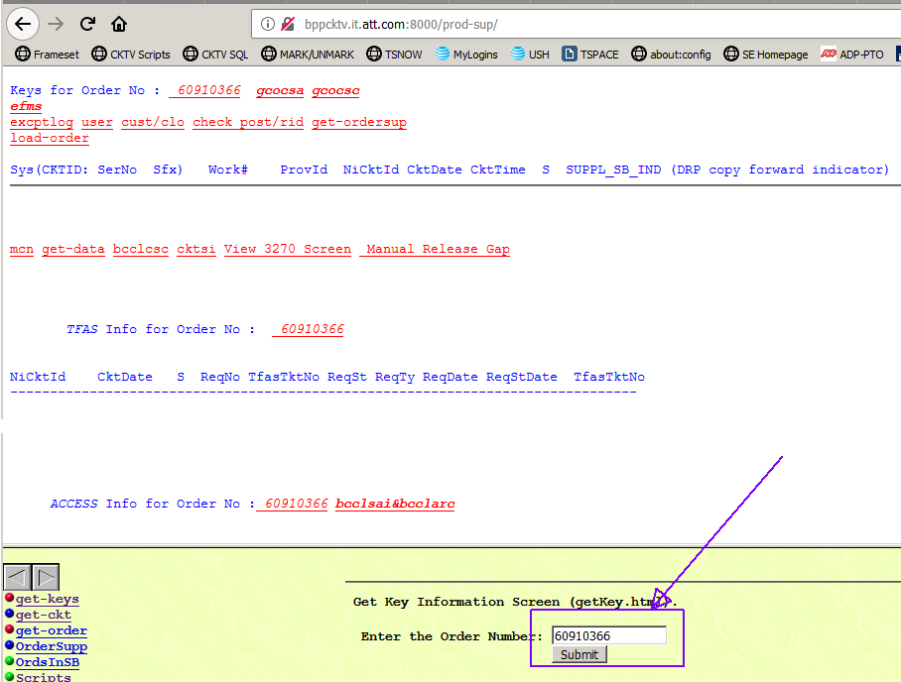

1. There are few different scenarios that may appear in the GetKeys GUI

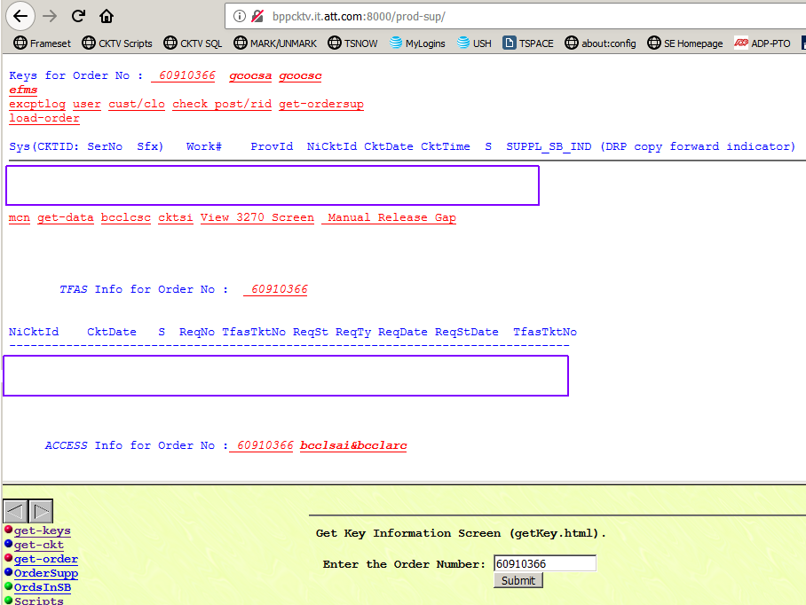

4. Note that the data fields are all empty. This order is not loaded

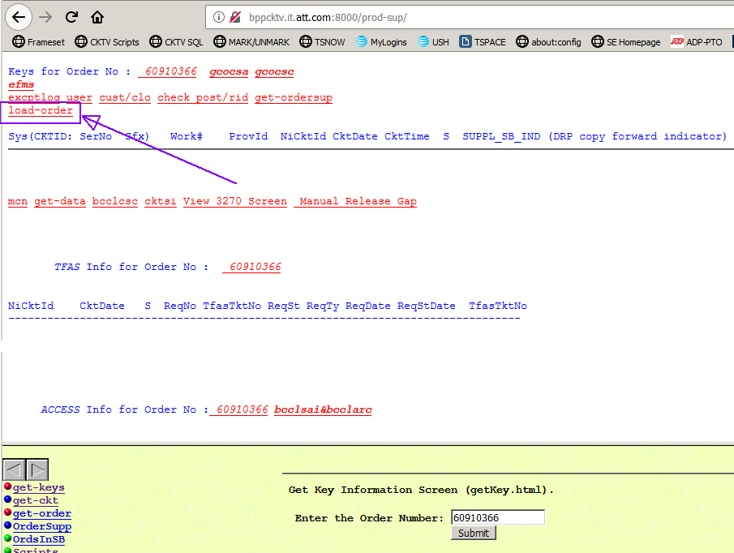

**5.** The order load dialogue appears in the lower right portion of the screen. Select the radio button to load the proper SUPP -- The proper SUPP has "**bk**" in the name.

- If there is no option with "**bk**", jump to **SECTION SIF LOAD METHOD**.

- Click Submit button just below the SUPP radio buttons to start the load process.

- Wait for about 1 - 2 minutes*:

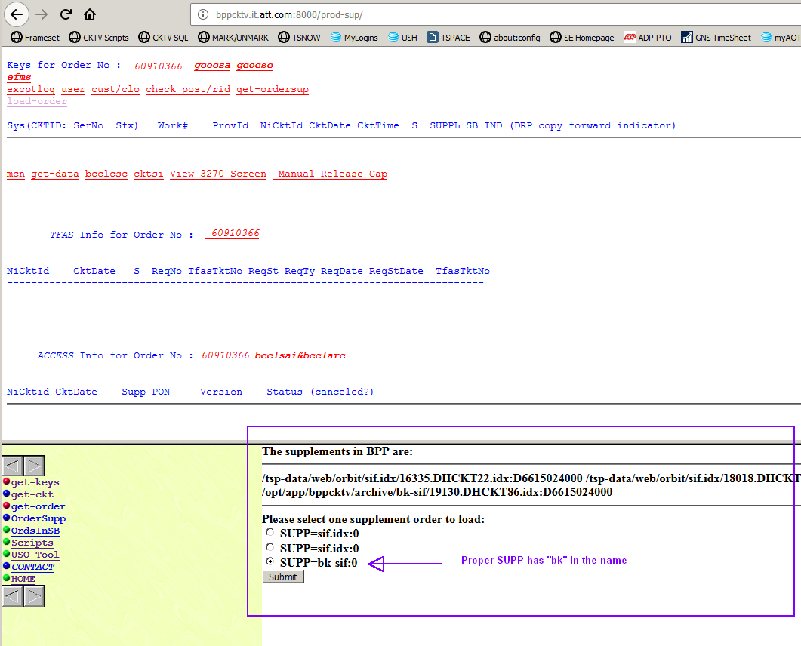

6. When order loading process is complete, the lower right hand of the webpage will populate with info. Click the Order No hyperlink to refresh the GUI....we need to see if order data is populating in the GUI...:

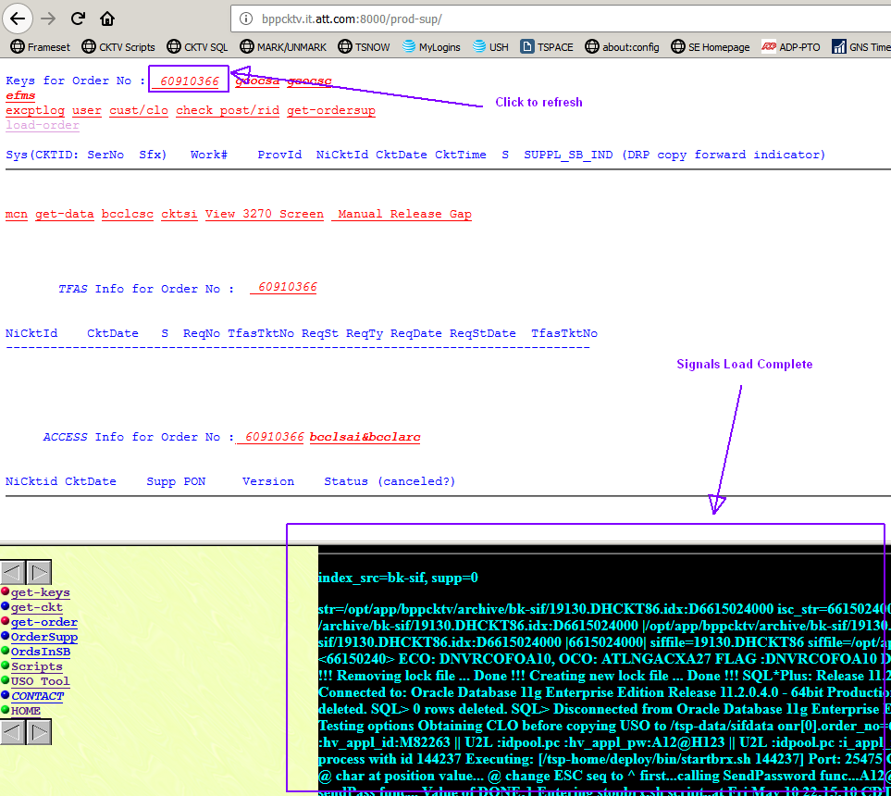

7. Getkeys GUI @ http://bppcktv.it.att.com:8000/prod-sup/reveals a partially loaded order. This is a very common interim stage of processing -- ie: the upper line with circuit data populates first -- and the TFAS Info line is all blank.

We should wait some minutes (about 3 minutes* ) before pushing the order with the tgo2sb script. Most often, automation can and will fill all the order data on the GUI. But if the order stays in this state more than 5 minutes*, then we should begin to push the order along with the tgo2sb script.

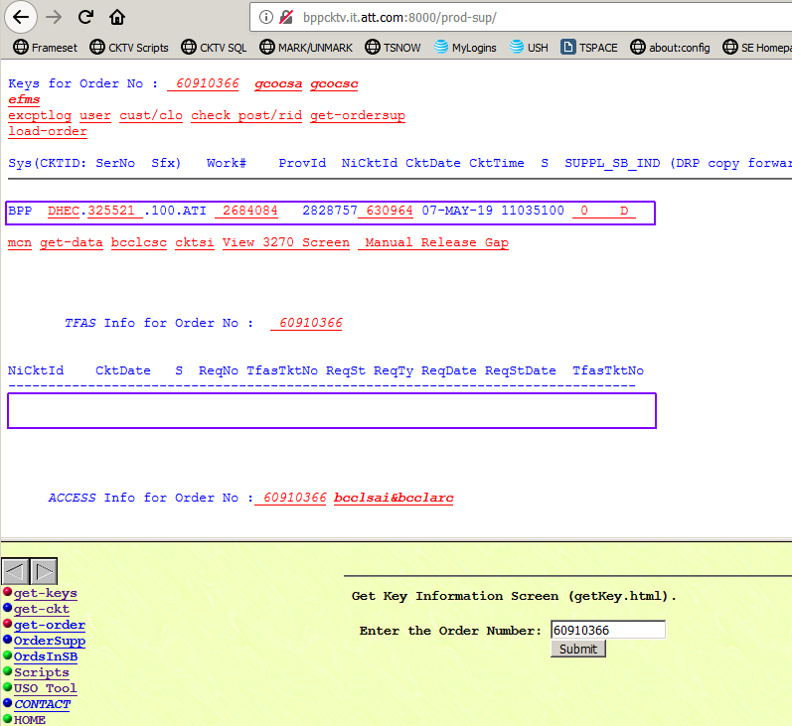

8. Scrape the WORK NUMBER from the GetKeys GUI @ URL <http://bppcktv.it.att.com:8000/prod-sup/>. (This case is 2684084)

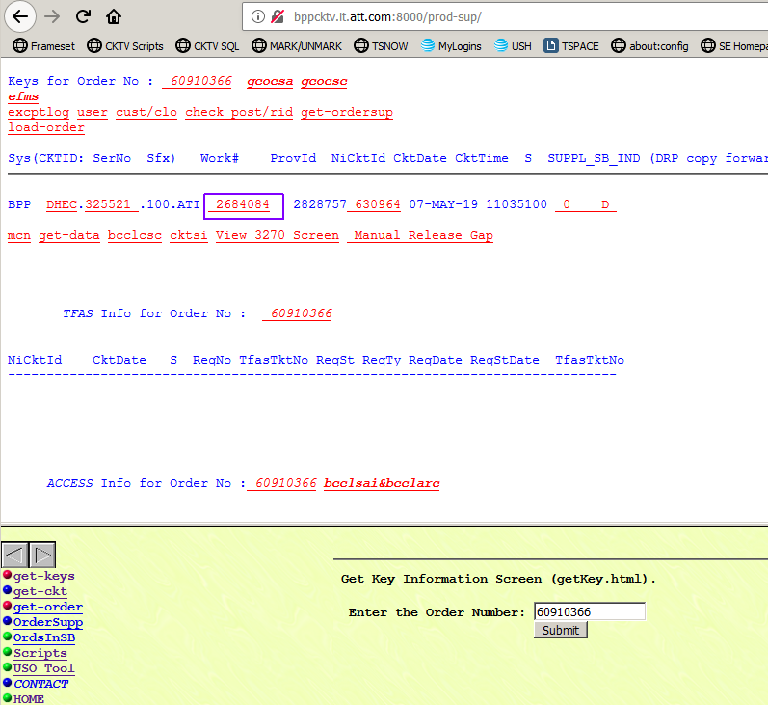

9. Proceed to Production Support scripts @ URL http://bppcktv.it.att.com:8000/prod-sup/wrapper/ps-index.html

- Select script tgo2sb

- apply parameters appropriate scheduling block from the list and 2684084 ( the WORK NUMBER ) to the input box as shown...

- and click EXECUTE button.

This is the sequence of scheduling blocks to be applied to an order that does not progress and fill the upper circuit line and lower TFAS Info line per our previous illustration:

0700

0705

0300

0310

0320

NOTE: you must check the progress of the order by refreshing the GetKeys GUI after each schedule block that you push. In some cases, pushing 0700 once will be enough to carry the order through all automation to fully populate the GetKeys GUI data. Some order may only need 0700, then 0705... and automation will itself carry out the remaining steps (0300, 0310... etc)

In example, we will push schedule block 0700 first.... :

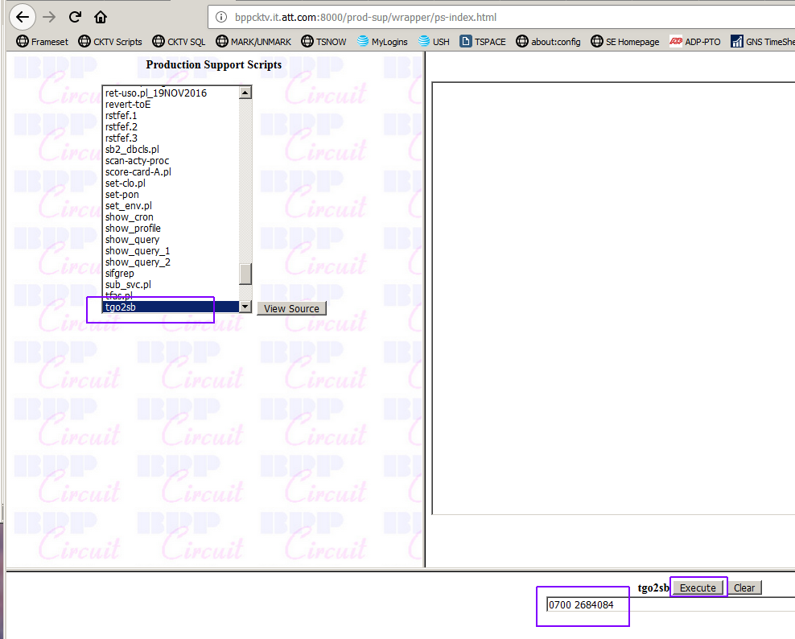

then we will go back to the GetKeys GUI to check progress. Click the Order No hyperlink to refresh the GUI....we need to see if order data is populating in the GUI.

9. Wait a minute or two* and refresh again. If there is no progress, we will push the next schedule block sequence:

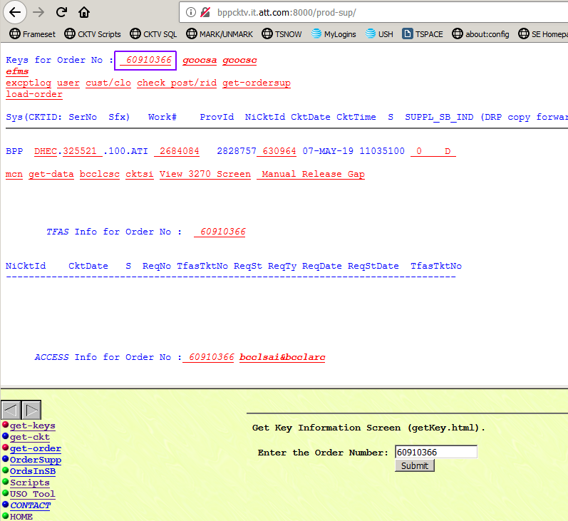

**10.** Per last image of GetKeys, the order data population process has not progressed. So, we will now push the next schedule block sequence -- which in this case -- is 0705. Click Execute button....

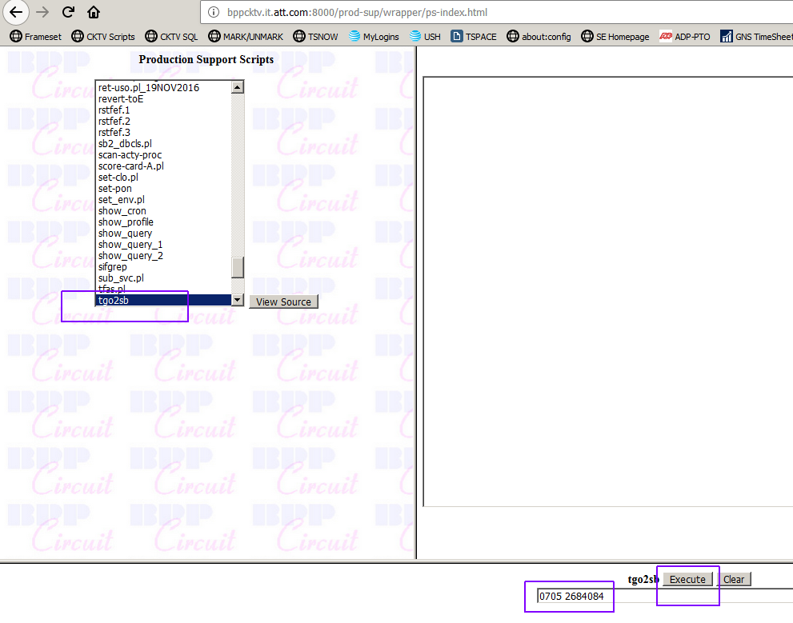

...and return to the GetKeys GUI to check progress. Click the Order No hyperlink to refresh the GUI....we need to see if order data is populating in the GUI. If there is no progress, we will push the next schedule block sequence which will be 0300:



11. Per last image of GetKeys, the order data population process has not progressed. So, we will now push the next schedule block sequence -- which in this case, is 0300. Click Execute button

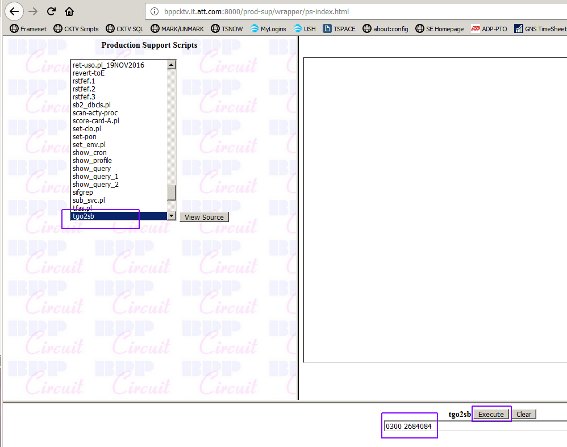

Return to the GetKeys GUI to check progress. Click the Order No hyperlink to refresh the GUI....we need to see if order data is populating in the GUI. If there is no progress, we will push the next schedule block sequence which will be 0310. However -- look -- the TFAS Info line has begun to populate at last:

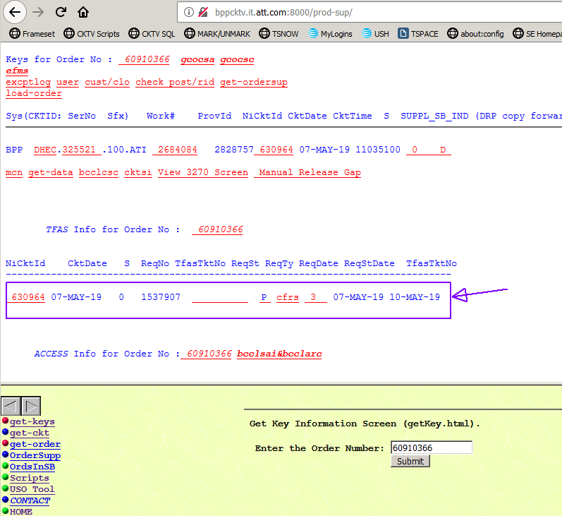

13. Optionally, we might have to repeat this push-and-check, push-and-check through the 0310 and 0320 scheduling blocks. It is unpredictable how many iterations of manual intervention may be needed. Sometimes just the push to 0700 is sufficient to carry the order to full order data population, then others all of the blocks need to be pushed (0700, 0705, 0300, 0310, 0320).

This order --unless it is a Quick Release Disconnect (QRD) -- is ready for TFAS. Proceed

**SIF LOAD METHOD**

You should skip this section if a radio button with "bk" option appears in the GetKey GUI order load dialogue in previous step.

1. Note that in this scenario, there is no radio button with the 'bk' option in the GUI. Hence, we will have to locate the related order SIF file on the CKTV server. For some reason, the indexes were not properly built, so we will manually intercede and repair.

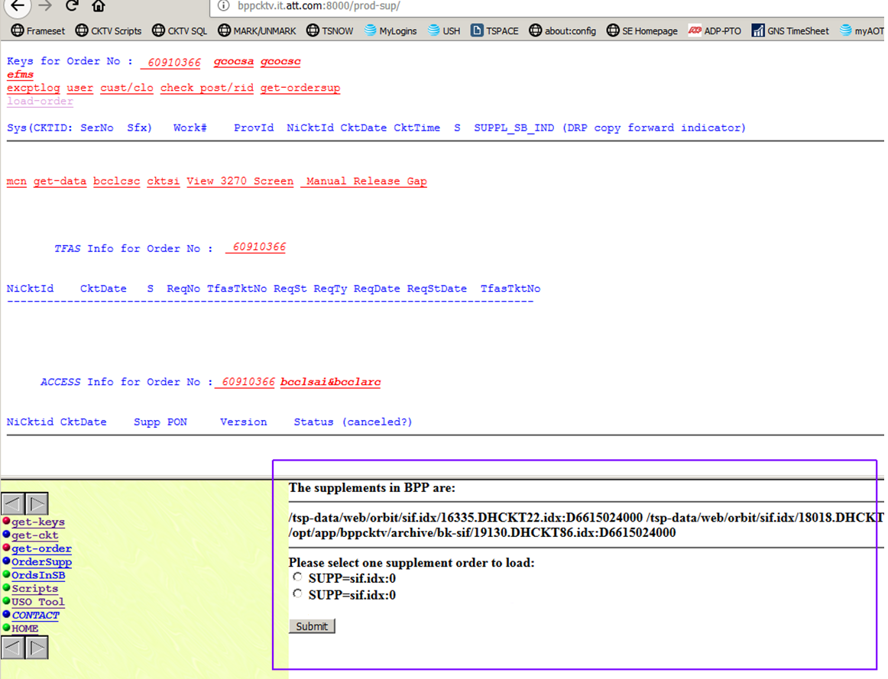

1. Proceed to BPP Circuit Database Query @ http://bppcktv.it.att.com:8000/sql/index.html and perform query:

SELECT * FROM SIFUSO WHERE ORDER_NO in ('60910366')

We are especially interested in the INSERTION_DATE value. In a later step, we will search for a source data SIF file in the CKTV archives which has the desired order data. USO numbers get reused almost annually, and so the USO may appear in multiple SIF files. The file with the desired order data will have a date stamp that matches this date in the SIFUSO table.

NOTE: If no row is retuned by the query, then we will simply use the SIF file with the most recent date stamp. In fact, this is the most common scenario. That is to say, the SIFUSO INSERTION_DATE value is almost always the most recent order date instance.



1. Using putty Login to server zlp10984.vci.att.com

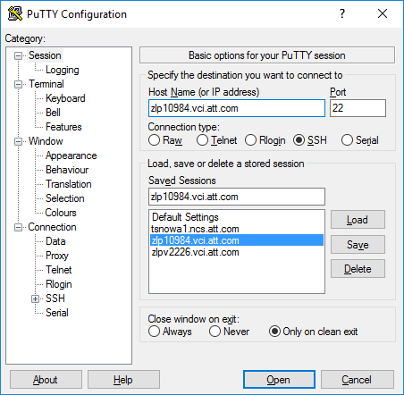

1. Log in using AT&T Id and RSA Soft token

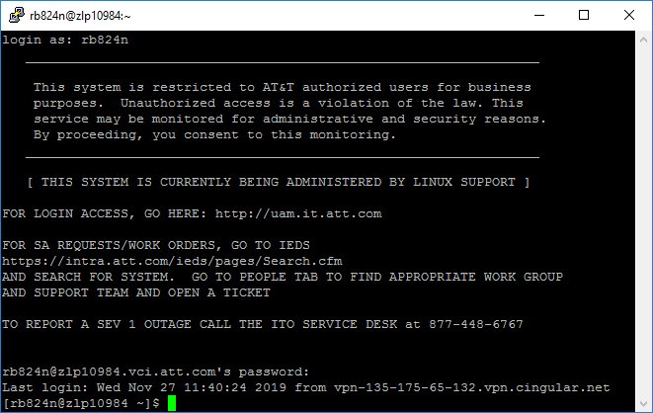

1. sudo su - tsphost.

Change directory to :

cd /aft/AFT/15487C_sifKbCp

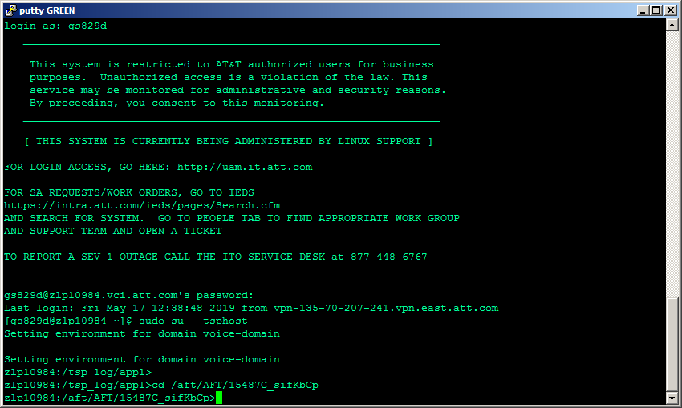

1. Perform the grep command:

grep '60910366' *

where '60910366' is the sample order number. Wait for the unix prompt to return.

NOTE: there is no guarantee that the prompt will return in less than 5 minutes. This scenario took 3 minutes.

The last file found is usually the desired file, and will generally have the highest number as well. This search matched these files:

Binary file 16011.TPAI143.kb.tmp matches

Binary file 16284.TPAI122.kb.tmp matches

Binary file 17010.TPAI101.kb.tmp matches

Binary file 17229.TPAI101.kb.tmp matches

Binary file 18123.TPAI101.kb.tmp matches

Binary file 19127.TPAI101.kb.tmp matches

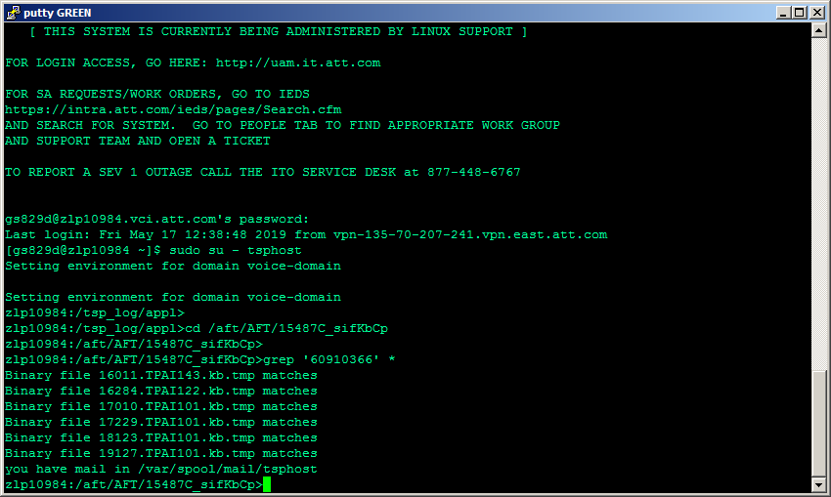

1. Let's test the last term returned ("Binary file 19127.TPAI101.kb.tmp matches" ) .

Stripping away the non-filename text, we get:

19127.TPAI101.kb.tmp

...and we will use the list command to discover the file date stamp:

ls -al 19127.TPAI101.kb.tmp

...and the response is:

-rw-rw-r-- 1 tsphost tsphost 3251376 May 7 10:50 19127.TPAI101.kb.tmp

SUCCESS: The file date stamp of 07 MAY matches the SIFUSO INSERTION_DATE ( 07-MAY-19 ) value discovered in our previous SQL query. Hence, 19127.TPAI101.kb.tmp is the desired SIF file.

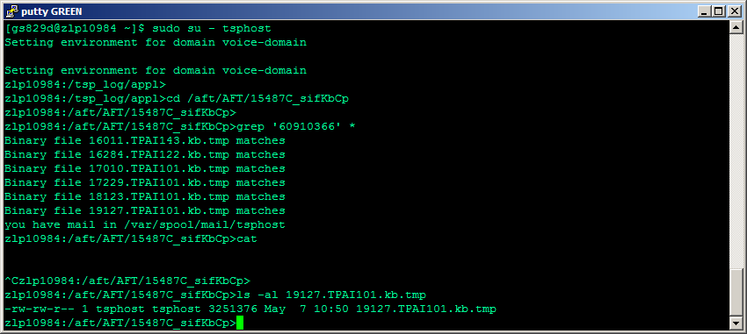

**6.** Perform this copy command to bring the SIF file to the USO Tool directory:

cp <FOUND_FILE> /tsp-data/web/orbit/uso/<ORDER_NO>.0

Replace the template values with realtime values:

cp 19127.TPAI101.kb.tmp /tsp-data/web/orbit/uso/60910366.0

...and execute ...and change directory to the USO Tool directory, and list:

cp 19127.TPAI101.kb.tmp /tsp-data/web/orbit/uso/60910366.0

cd /tsp-data/web/orbit/uso

ls -altr

SUCCESS: A large file named '60910366.0' having our order (and many others) appears in the USO Tool directory:

zlp10984:/tsp-data/web/orbit/uso>ls -altr

...

-rw-rw-r-- 1 tsphost tsphost 3251376 May 18 01:33 60910366.0

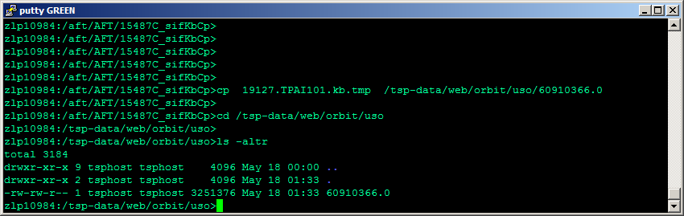

**7.** As we said in last step, many other orders reside with our desired order in the SIF file. We will use vi to manually edit the file to remove all other orders.

Open the file for editing:

vi 60910366.0

Where 60910366.0 is the ORDER_NO and file name that we just copied.

1. To get to that order in The file we get to Esc- :/Order_no in this case :/60910366

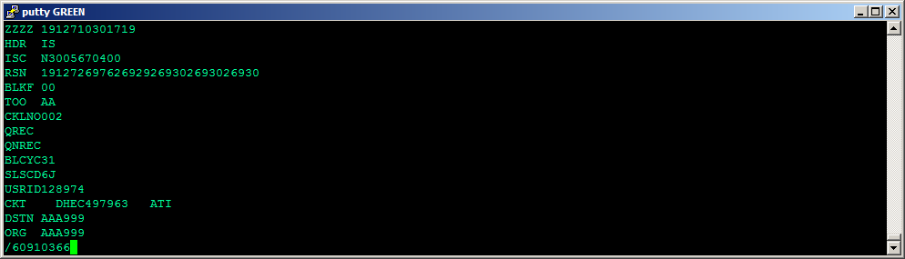

1. Once you get to the order Remove all the lines before your order, and all the lines after your order. Go 3 -4 lines up see the line number as shown in the image go to top using gg and delete line by just typing number and dd. Optionally save work here with vi write command ':w'

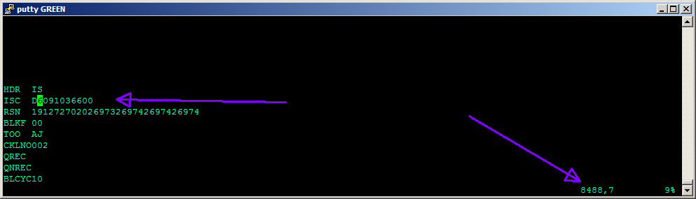

We have removed the data of all the other orders that **preceded** our ORDER_NO ( 60910366 ).

Esc + “: set list” - :set list is applied so that the right margin is visible

Paste 'ZZZZ 1912710301719'

NOTES:

Line #1 is the file header 'ZZZZ 1912710301719'

Line #2 is the 1st order data header 'HDR IS'

The colum of white dollar signs '$' show that every line in the file is padded with white spaces to a right margin of 35.

This margin must be maintained else the file may not load

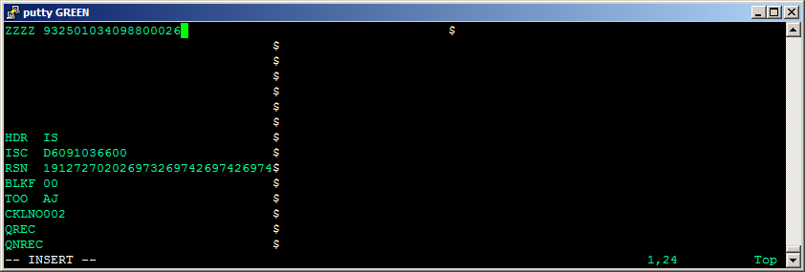

Go to end of this fine - Moving 200 lines forward we see the end of the order data is marked by 'ENDO 00193'

NOTE 1: Order data is not always 200 lines in length

Next we will remove all the data of all the other orders that **follow** our ORDER_NO ( 60910366 ).

Esc the insert Mode and delete everything below 5000000 dd

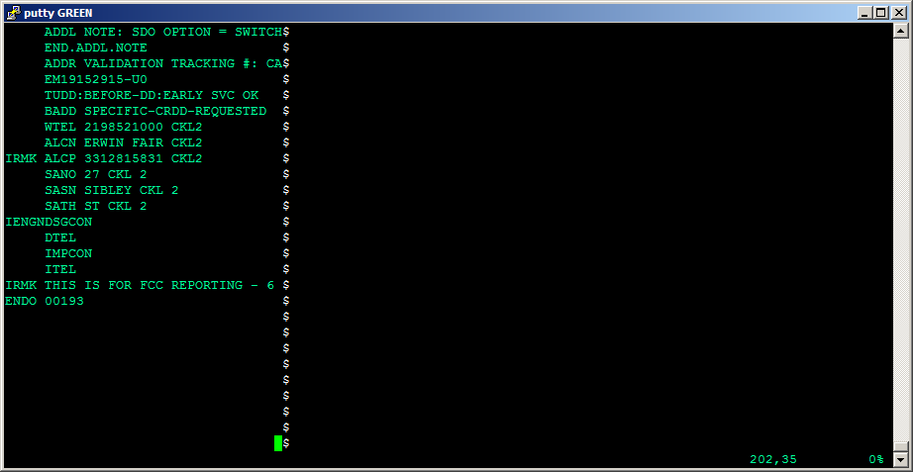

1. Once we delete everything below that line go back to insert “i” and paste

ENDSIF "

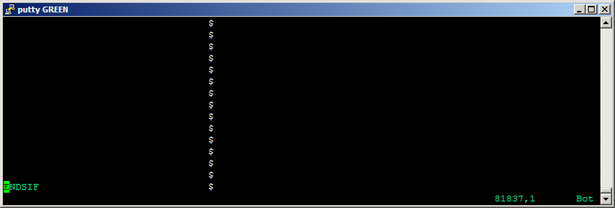

1. ESC-:-w
2. At the GetKeys GUI @ http://bppcktv.it.att.com:8000/prod-sup/ click "USO Tool" link:

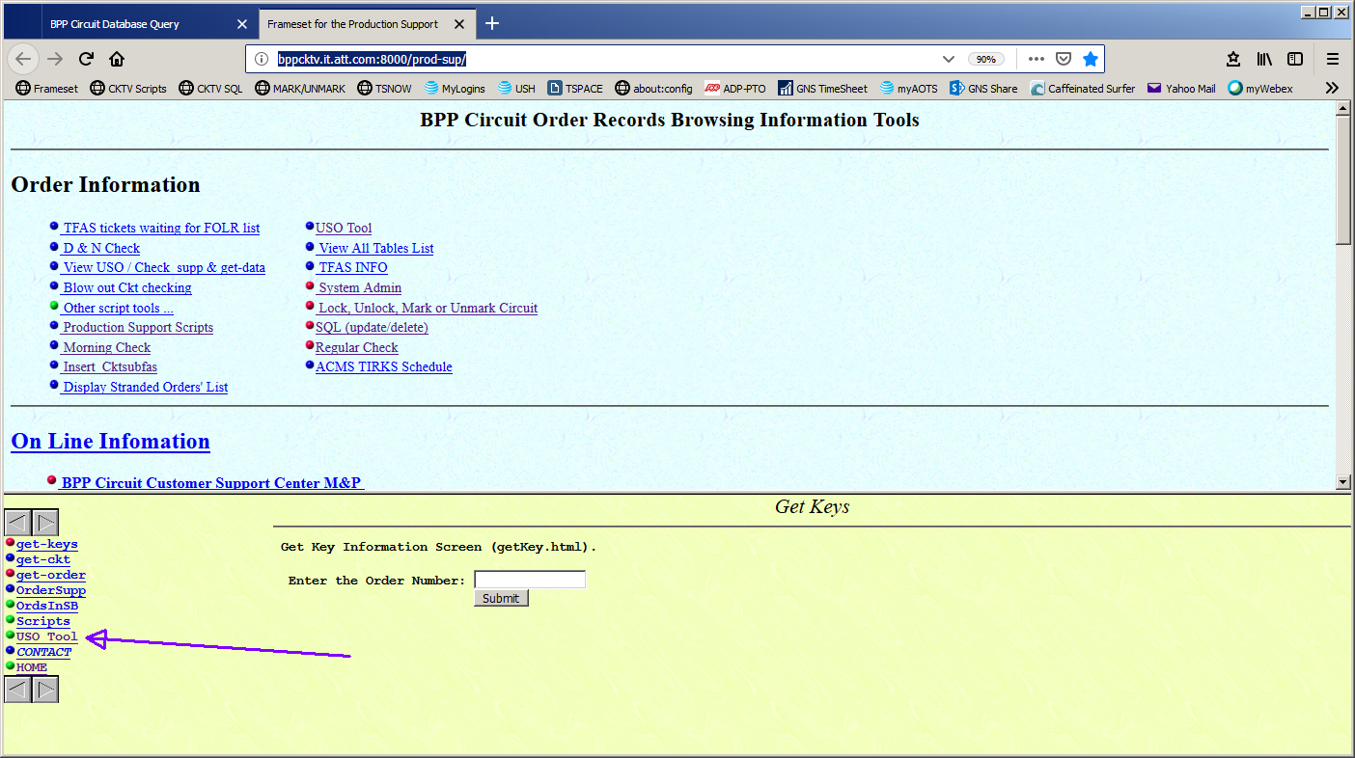

15. A new tab opens -- ' ASC USO TOOL' ... click on the "View USO DIR" link:

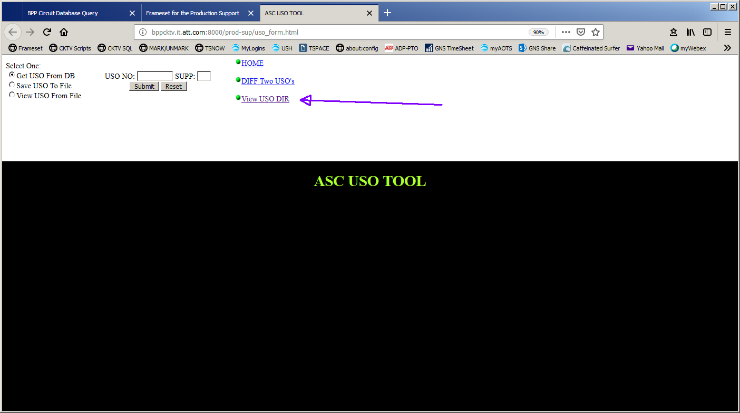

**16.** We can see the file (60910366.0 ) we just edited in unix some steps ago. This GUI page actually provides a view to the USO Tool directory on the server, along with some helpful hyperlinks.

To load the USO, all we have to do is click the "load USO" link.

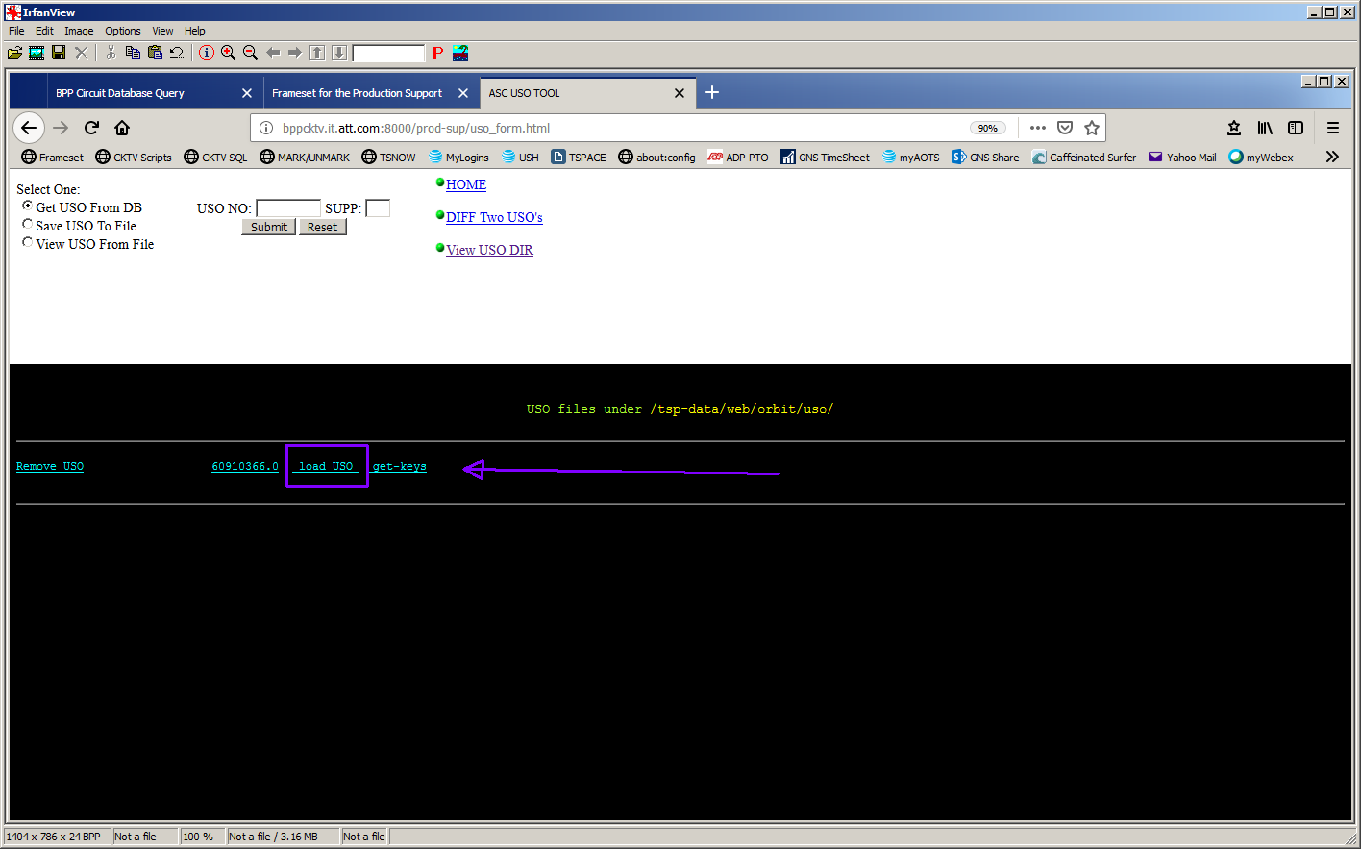

17. The GUI responds fairly quickly -- usually just a few seconds* -- by populating the web page as shown.

- None of the data is useful -- do not capture

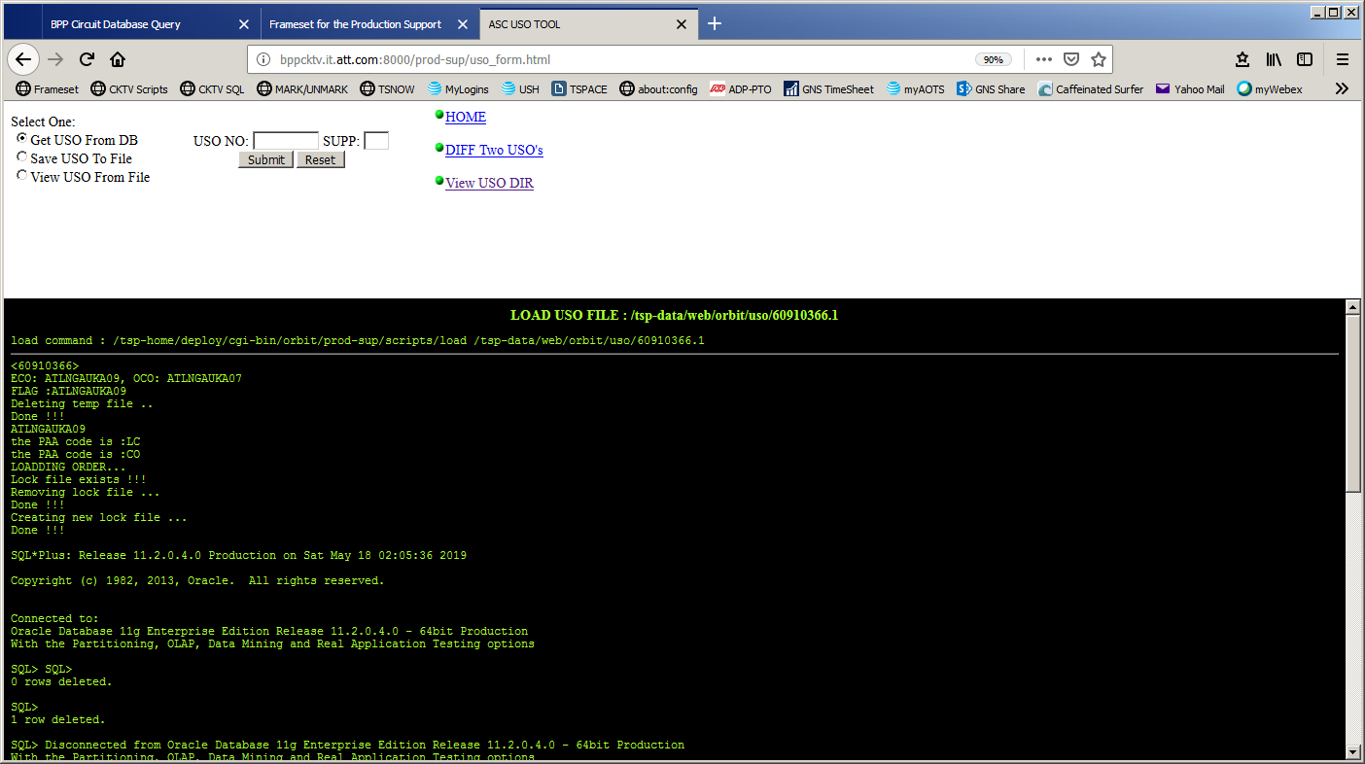

**18.** Proceed to GetKeys GUI @http://bppcktv.it.att.com:8000/prod-sup/ to check progress. Enter the order number into the "Enter the Order Number" field and click submit. Or Click the Order No hyperlink to refresh the GUI if the number is already entered....we need to see if order data is populating in the GUI. And follow the process of production Script.



19. There can be scenarios when this Load will fail. @ That time will go back to putty and check dates mentioned it the order SIF file.

esc- :/DD

You can go to desired line of dates by using Arrow key up and down from there. Delete the old dates update the new dates.

Note- Not all the dates are available in an order- Some dates can be missing, so whatever dates are available SIF file update those dates

Value of some dates which we update are shown in below screen shots

DD 09-13-19

SID 06-28-19

DLRD 07-22-19

RID 08-22-19

DVA 08-27-19

WOT 09-03-19

CTA 09-06-19

EIRD 07-01-19

FOD 07-02-19

CDLR 08-15-19

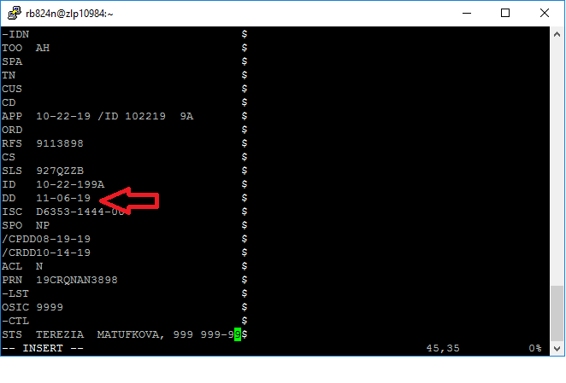

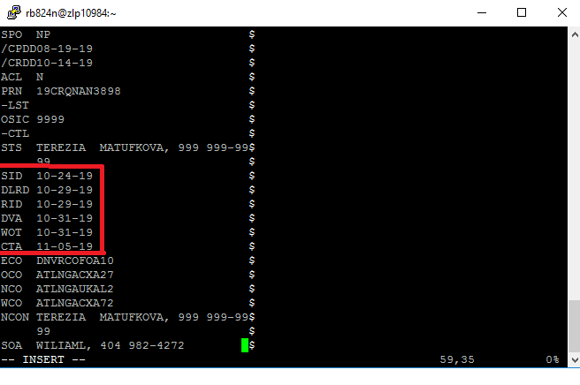

20. Every month our team goes to SIF file of healthy latest order and get those date and save it with us , so whenever we see the dates are old we update these dates and try to reload order. Please make sure you delete your previous loaded order. You wont see that on GUI but it would been loaded at back end. So go Production script page

Order_no Suppl_Seq NO- to delete Order

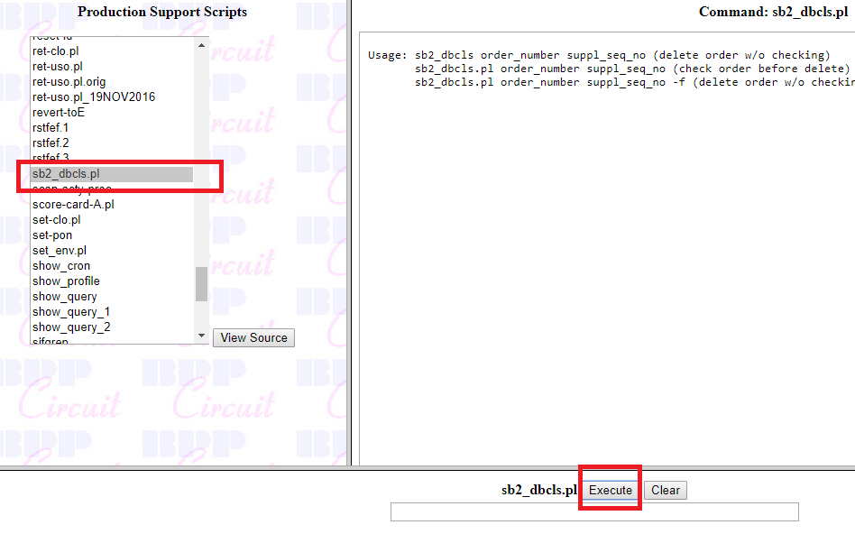

You Go back to get GUI Page and get to USO Tool



A new tab opens -- ' ASC USO TOOL' ... click on the "View USO DIR" link:



**.** We can see the file (60910366.0 ) we just edited in unix some steps ago. This GUI page actually provides a view to the USO Tool directory on the server, along with some helpful hyperlinks.

To load the USO, all we have to do is click the "load USO" link.



Proceed to GetKeys GUI @http://bppcktv.it.att.com:8000/prod-sup/ to check progress. Enter the order number into the "Enter the Order Number" field and click submit. Or Click the Order No hyperlink to refresh the GUI if the number is already entered....we need to see if order data is populating in the GUI. And follow the process of production Script.

